1. Install and configure Tomcat version 9 on your Linux machine with the Manager and Host Manager sections enabled.
- Check Java (Tomcat needs Java)
java -version

- If Java is not installed
sudo apt update
sudo yum install java -y
Tomcat runs on Java. Without Java, Tomcat won’t start.

- Create tomcat user
sudo useradd -r -m -U -d /opt/tomcat -s /bin/false tomcat
A dedicated non-login user to run Tomcat securely.
- Install wget
sudo yum install wget -y
Needed to download Tomcat from the internet.
- Download Tomcat
wget https://archive.apache.org/dist/tomcat/tomcat-9/v9.0.98/bin/apache-tomcat-9.0.98.tar.gz
Gets the specific Tomcat version archive.
- Create installation directory
sudo mkdir /opt/tomcat
Where Tomcat will be installed.
- Extract Tomcat
sudo tar xzvf apache-tomcat-9.0.98.tar.gz -C /opt/tomcat
Unpacks the downloaded archive into the install directory.
- Change ownership
sudo chown -R tomcat: /opt/tomcat
Gives the tomcat user control over Tomcat files.
- Make scripts executable
sudo chmod +x /opt/tomcat/bin/*.sh
Ensures startup/shutdown scripts can run.
- Create Tomcat service file
sudo vi /etc/systemd/system/tomcat.service
Defines how Tomcat will run as a service.
- Paste service config
[Unit]
Description=Apache Tomcat Web Application Container
After=network.target
[Service]
Type=forking
User=tomcat
Group=tomcat
Environment="JAVA_HOME=/usr/lib/jvm/java-21-openjdk"
Environment="CATALINA_PID=/opt/tomcat/temp/tomcat.pid"
Environment="CATALINA_HOME=/opt/tomcat" Environment="CATALINA_BASE=/opt/tomcat"
Environment="CATALINA_OPTS=-Xms512M -Xmx1024M -server -XX:+UseParallelGC"
Environment="JAVA_OPTS=-Djava.awt.headless=true
Djava.security.egd=file:/dev/./urandom"
ExecStart=/opt/tomcat/bin/startup.sh
ExecStop=/opt/tomcat/bin/shutdown.sh
Restart=on-failure
[Install]
WantedBy=multi-user.target
Configuration for Tomcat user, paths, and options.
- Reload systemd
sudo systemctl daemon-reload
Apply the new service file.
- Start Tomcat
sudo systemctl start tomcat
Launches Tomcat immediately.
- Enable at boot
sudo systemctl enable tomcat
Ensures Tomcat starts on system reboot.
- Check status
sudo systemctl status tomcat
Confirms if Tomcat is running.

- Access in browser
http://3.87.171.8:8080/
Open Tomcat welcome page (default port 8080).
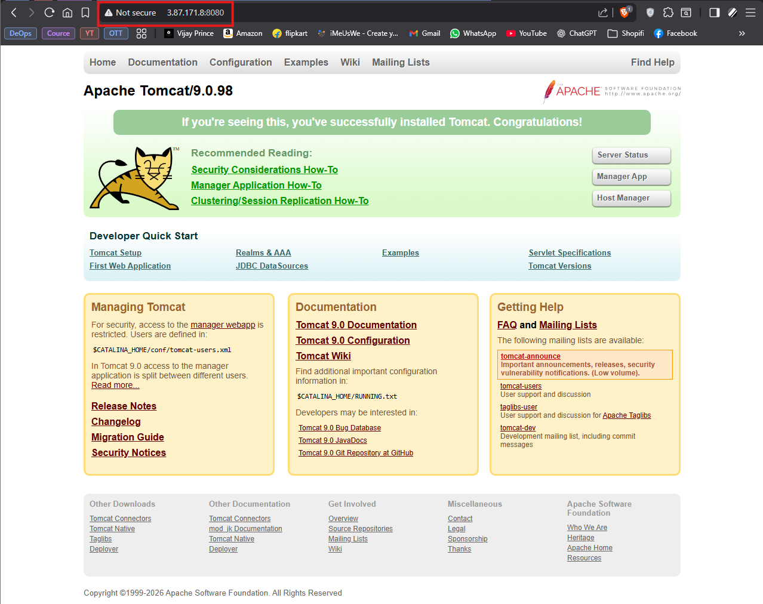
- Server status
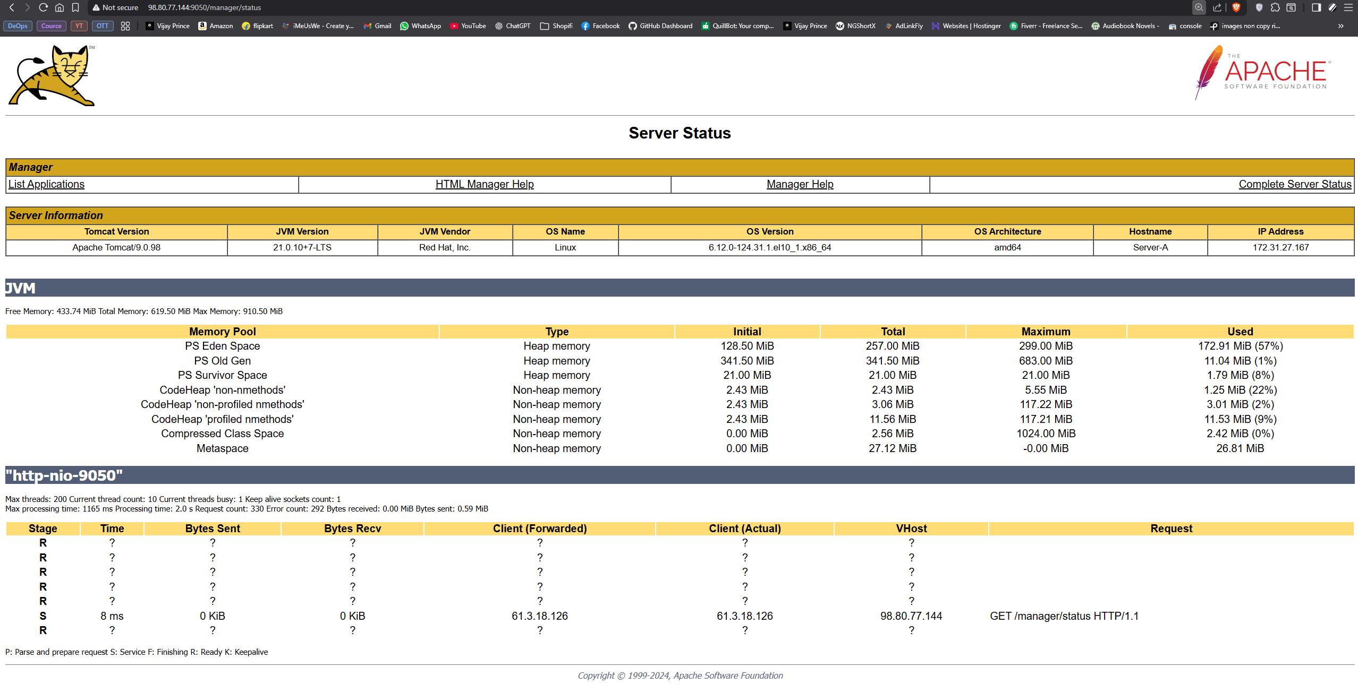

- Manager App
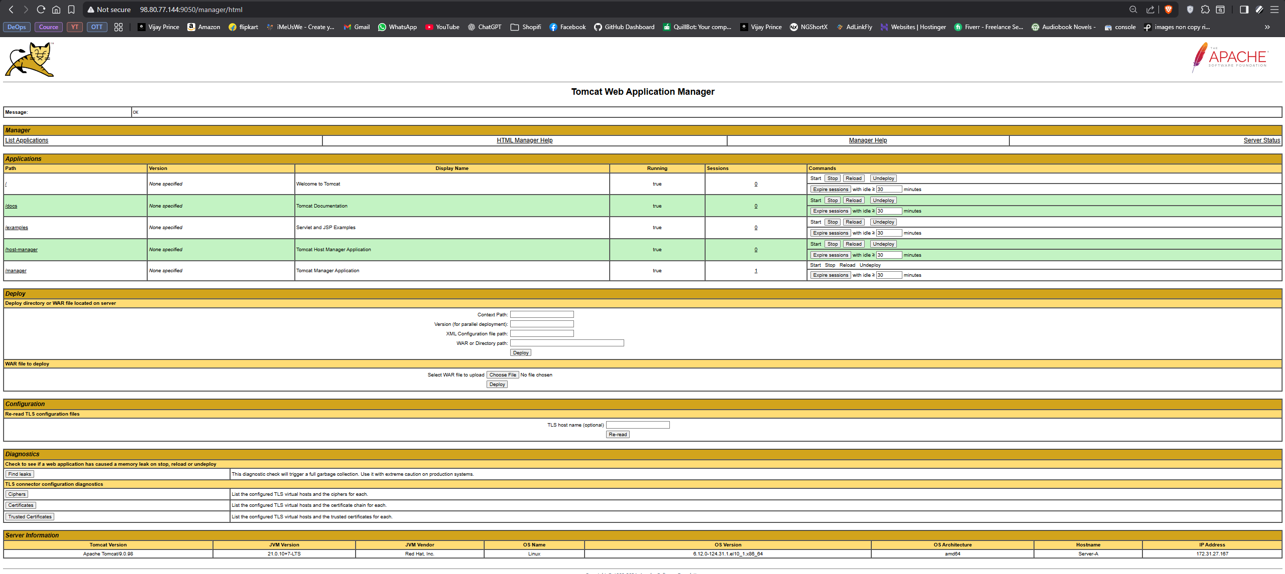
- Host Manager
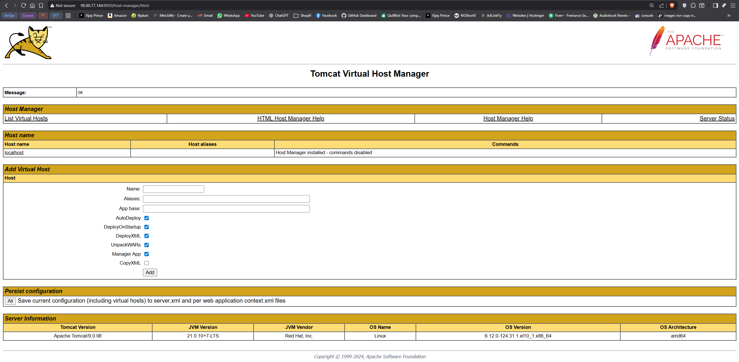

2. Change the default Tomcat port to 9050.
- Edit Tomcat Port
sudo vi /opt/tomcat/conf/server.xml
Open the main Tomcat config file.
- Change port
:%s/8080/9050/g
Replace all 8080 with 9050.
- Save & quit
:wq
Write changes and exit editor.
- Restart Tomcat
sudo systemctl restart tomcat
Apply the new port configuration.
- Check listening port
sudo ss -tulnp | grep 9050
Verify Tomcat is running on 9050.
- Open firewall port
sudo firewall-cmd --permanent --add-port=9050/tcp
sudo firewall-cmd --reload
Allow external access to 9050.
- Access in browser
http://3.87.171.8:9050/
Use new port 9050.
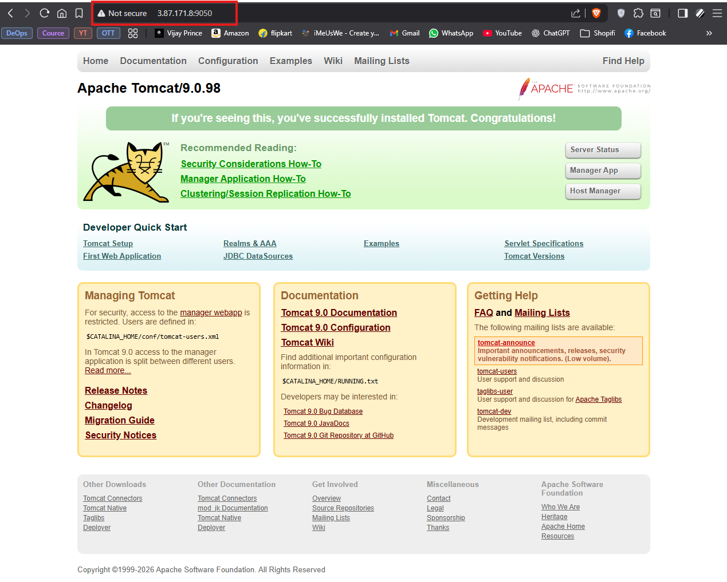

3. Create a new user and configure the necessary settings for secure login via Putty or other remote access tools.
- Connect to EC2
# AWS Machine (Linux) ssh -i zoro.pem ec2-user@3.87.171.8
Login as default user using your key.
- Create new user
sudo useradd devivaraprasad
Adds a new system user for secure login.
- Set password (optional)
sudo passwd devivaraprasad
Assigns password if needed (not required for key login).
- Give sudo permissions
# Amazon Linux / CentOS sudo usermod -aG wheel devivaraprasad
Allows the new user to run admin commands.
- Create .ssh directory
sudo mkdir /home/devivaraprasad/.ssh
sudo chmod 700 /home/devivaraprasad/.ssh
Stores authorized keys for the new user.
- Copy authorized keys
sudo cp /home/ec2-user/.ssh/authorized_keys /home/devivaraprasad/.ssh/
Reuses existing key from ec2-user.
- Set correct permissions
sudo chown -R devivaraprasad:devivaraprasad /home/devivaraprasad/.ssh
sudo chmod 600 /home/devivaraprasad/.ssh/authorized_keys
Ensures only devivaraprasad can access SSH keys.
- Test SSH login
# Linux / Mac ssh -i zoro.pem devivaraprasad@3.87.171.8
Connect as new user using same key.
- Windows Subsystem for Linux Host: devivaraprasad@3.87.171.8, select existing .pem key.
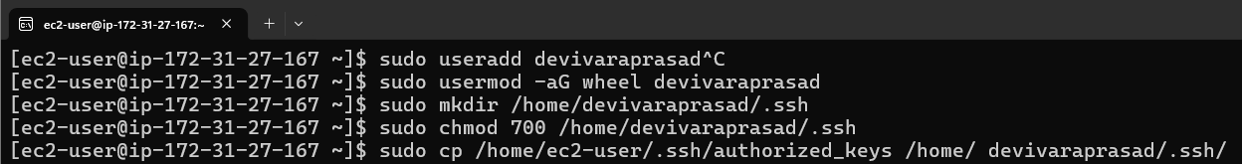
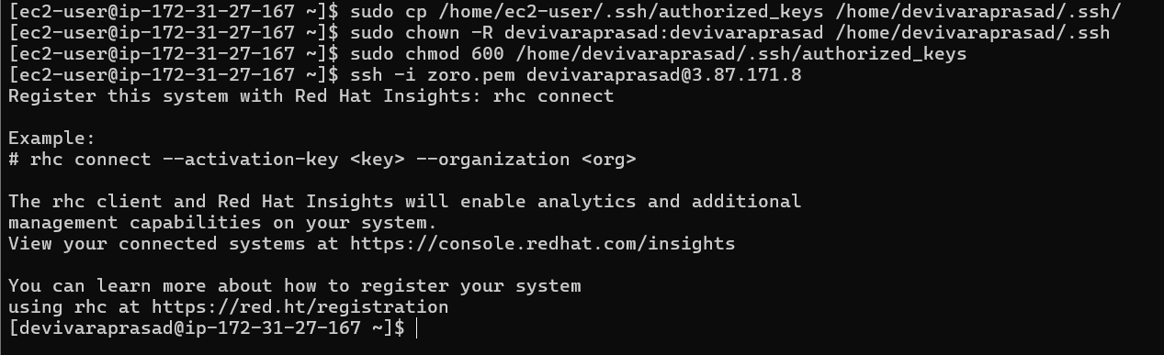

4. Establish passwordless connection between two linux servers
Server A (remote /source): 3.87.171.8 (your EC2 server) where you run ssh-keygen
Server B (remote/target): 34.229.202.93 (your EC2 server)
- Generate SSH key
ssh-keygen -t rsa
Creates a new RSA key pair for passwordless login.
- Verify keys
ls -l ~/.ssh/
Check that private and public keys are created.
You should see files like:
id_rsa (private key)
id_rsa.pub (public key)
- View public key:
cat ~/.ssh/id_rsa.pub

- Append to remote target server
echo “” >> .ssh/authorized_keys (in 34.229.202.93)
Add public key to authorized_keys.

- Test passwordless login
ssh ubuntu@34.229.202.93 (in 3.87.171.8)
Connect from Server A without password
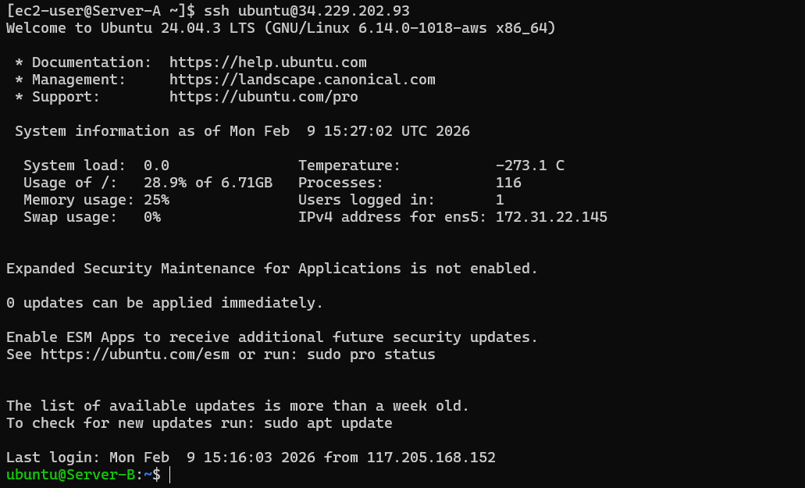

5. Create a new user account on your Linux machine and grant them sudo privileges.
- Create new user
sudo useradd newuser
Adds a new system user.
- Add user to sudo group
sudo usermod -aG sudo newuser # Ubuntu / Debian
sudo usermod -aG wheel newuser # CentOS / RHEL / Amazon Linux
Gives admin privileges.
- Verify sudo access
su newuser
Switch to new user.

- Test sudo
sudo whoami
Run a command as sudo to confirm privileges.

- Test passwordless login
ssh ubuntu@34.229.202.93 (in 3.87.171.8)
Connect from Server A without password
Output should be: root
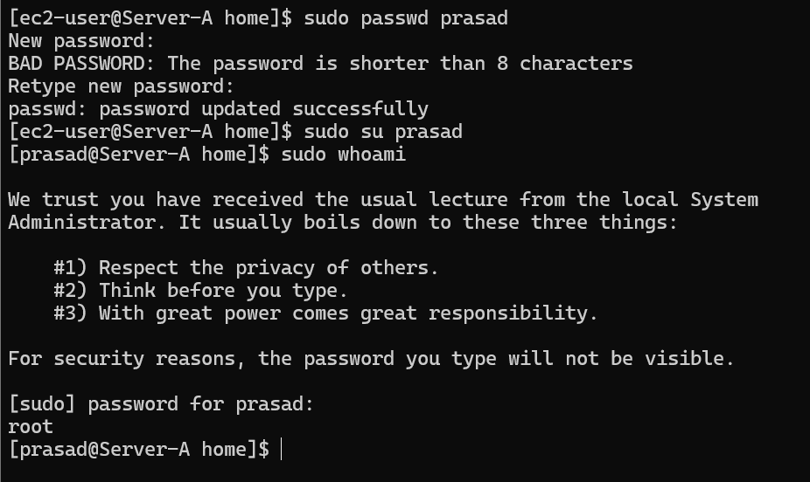

6. Use the 'scp' command to securely copy files and directories between Linux machines without password
- Copy a single file
scp f9.sh ubuntu@34.229.202.93:/home/ubuntu/
Securely transfer a file to a remote server.
- Copies f9.sh to /home/ubuntu/ on remote server.

- Copy entire directory
scp -r king ubuntu@34.229.202.93:/home/ubuntu/
Transfer a folder recursively.
- Copies the full king/ directory and all contents to remote server.
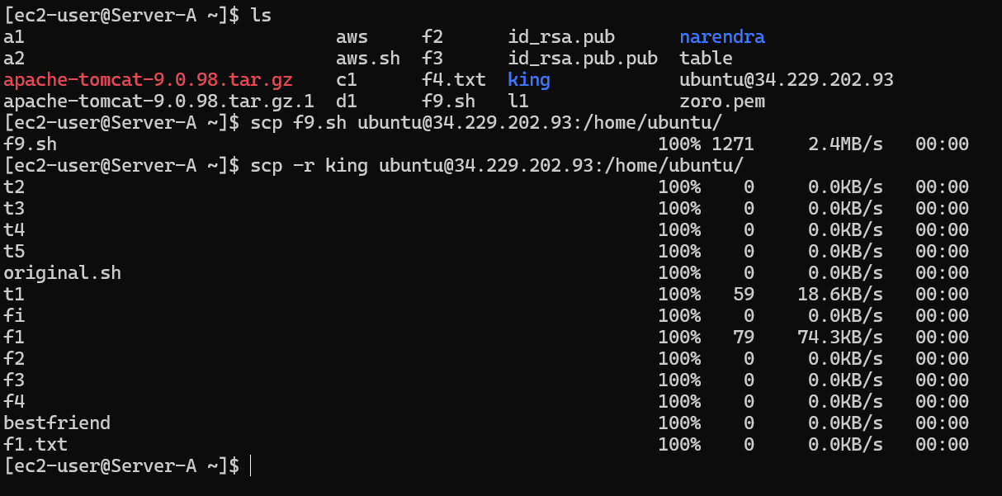
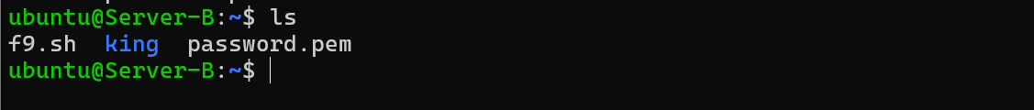
7. How can you list the contents of a tar.gz file and extract a particular file
- List contents
tar -tzf apache-tomcat-9.0.98.tar.gz
View all files inside a tar.gz archive without extracting.
- Shows detailed list of all files in the archive.
- List contents
tar -xzf apache-tomcat-9.0.98.tar.gz apache-tomcat-9.0.98/conf/server.xml
Extract only a specific file from the archive.
- Extracts path/to/file from the tar.gz archive without unpacking everything.

8. How can you compress a directory or file into a tar archive on Linux
- Compress a directory
tar -czf backup.tar.gz /home/ec2-user/king/
Create a tar.gz archive from a folder.
- Compresses tomcat/ directory into king.tar.gz.
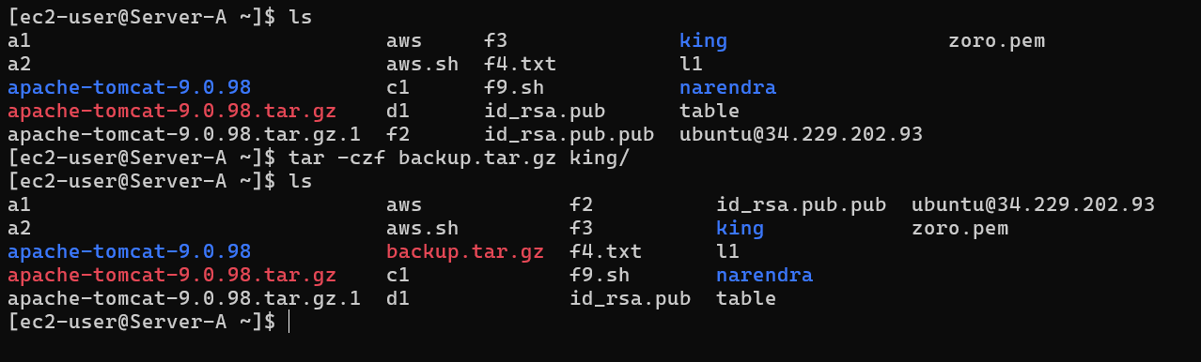
- Compress multiple files
tar -czf archive.tar.gz file1 file2 file3
Include specific files in one archive.
- Compresses file1, file2, file3 into archive.tar.gz.
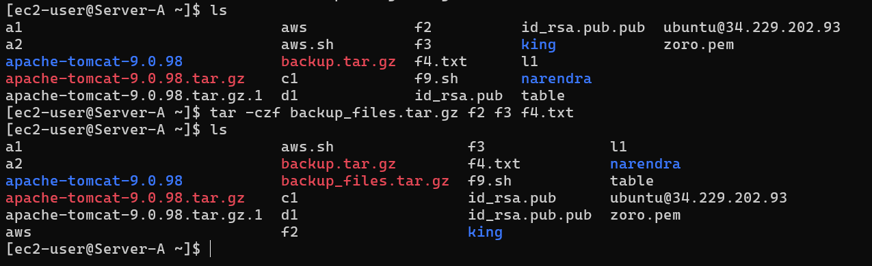
- List contents: tar -tzf archive.tar.gz
- Extract one file: tar -xzf archive.tar.gz path/to/file
- Compress: tar -czf archive.tar.gz

9. Write a command to synchronise files and directories between 2 local folders
- Basic sync → One-way sync without deleting extra files.
rsync -av /home/user/folder1/ /home/user/folder2/
Synchronises changes from folder1 to folder2 without removing extra files.
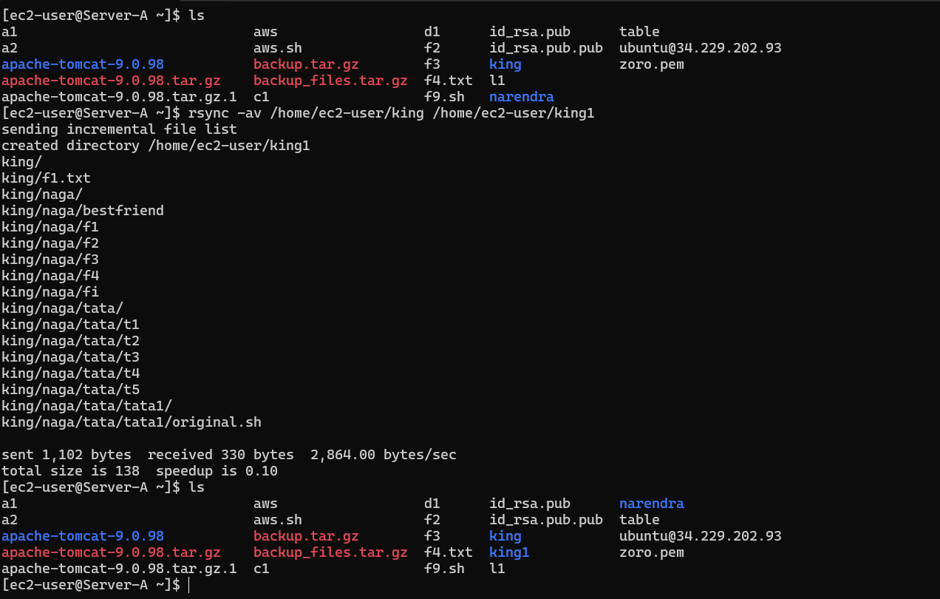
- Mirror sync → Exact copy, deletes files not in source.
rsync -av --delete /home/user/folder1/ /home/user/folder2/
Ensures folder2 exactly matches folder1.
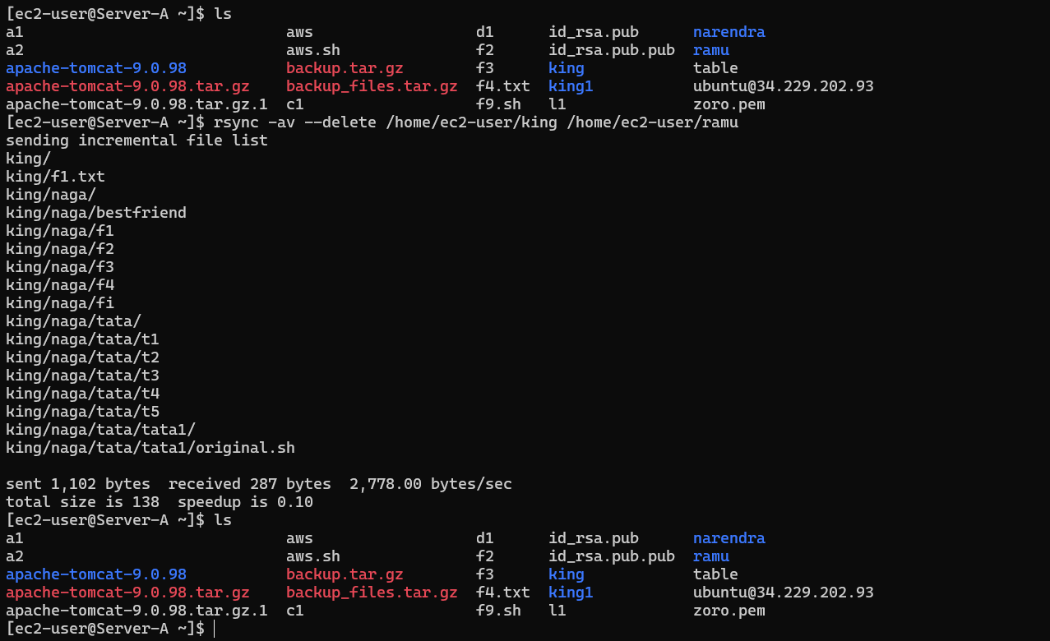
Quick flags summary →
- -a archive mode (preserves permissions, timestamps, symlinks)
- -v → verbose (shows progress)
- --delete → remove files from destination not present in source
10. What is load average and swap memory in Linux
Load Average → shows the average number of processes that are running or waiting for CPU (and uninterruptible I/O) in the system.
uptime Used to check load average
➡ The three load average values represent system load for 1, 5 and 15 minutes respectively.
Swap Memory → is disk space used by Linux as virtual memory when physical RAM is not sufficient.
It helps prevent applications from being terminated when RAM becomes full.
free -h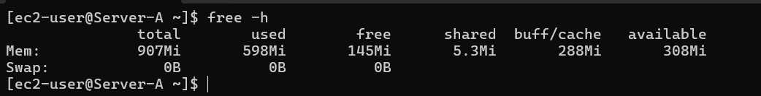
The Swap row shows the total swap space, used swap and free swap on the system.
11. What are the important system directories in linux and what are they genereally used for [Ex: var, home etc]
Root directory → Base of the filesystem.
/
Essential user binaries → Commands like ls, cp.
/bin
System binaries → Admin commands like ifconfig, fsck.
/sbin
Boot files → Boot loader, Linux kernel, initramfs.
/boot
Device files → Hardware devices like /dev/sda.
/dev
System configuration → Stores configuration files.
/etc
User home directories → Each user’s personal files.
/home
Libraries → Shared libraries for binaries.
/lib
Variable data → Logs, spool files, mail, etc.
/var
Temporary files → Cleared on reboot.
/tmp
User programs/data → Contains /usr/bin, /usr/lib.
/usr
Optional software → Third-party packages.
/opt
Root home → Home directory for root user.
/root
Temporary mount points → For disks mounted temporarily.
/mnt
Removable media → USB, CD-ROM mount points.
/media
Service data → Data for services like HTTP, FTP.
/srv

12. What are the package installers for Redhat, Ubuntu, Debian, CentOS, Alpine
RedHat / CentOS → Uses YUM or DNF for package management.
sudo yum install package-name # Older systems
sudo dnf install package-name # Newer systems
Ubuntu / Debian → Uses APT (Advanced Package Tool).
sudo apt update
sudo apt install package-name
Alpine Linux → Uses APK (Alpine Package Keeper).
sudo apk add package-name

